  School of Computer Science | COMP2120-1-R-2025S  Object Oriented Programming using Java  Summer 2025  Midterm Exam

Total Marks: 35 Total Time: 60 Minutes
Start Time: 8.40 AM End Time: 9.40 AM (June 25)

Notes:
- Clearly identify the number of the question you are answering.
- You are not allowed to search on the internet to find any help or look at the slides.
- Don’t spend too much time on a single problem. If you get stuck, move on to something else and come back later.

- State whether the following statements are true or false (T/F)? (15 x 1 = 15 Marks)

  - A variable of type long in Java takes 8 bytes in memory. True
  - The following is an example of a valid identifier: 1stPlayer False
  - The operators *, /, %, + and - all have the same level of precedence. False
  - An import declaration is not required when one class in a package uses another in the same package. True
  - A zero given in the argument of the System.exit method indicates an abnormal termination of the program. False
  - Instance variables of type integer are given zero value by default. True
  - Both operands of the operator (i.e., |) will be evaluated in the following statement: ((x>y)|(y>z)); True
  - The following two statements are equivalent and valid statements: a) int [] a ={1,2,3}, b={4,5,6}; b) int a [] ={1,2,3}, b={4,5,6}; False
  - Consider a class called student that has a public method called print() that prints the properties of a student object (e.g., name, id, etc.). The following is an example of a valid code:
Student student[] = new Student[10];
for(int i=0; i<10; i++){
student[i].print();
} False
  - The compiler will not provide a default constructor if you write a constructor with more than one parameter. True
  - You cannot call a method or access an instance variable using this inside a static method. True
  - A class can contain both of the following method definitions
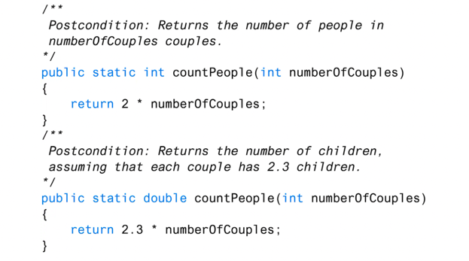
False
  - Consider a class A that has a private instance variable count. You can access the variable count as follows inside the main method that is also located in A. True
class A {
private int count;
//code goes here
public static void main (String args[]){
A a = new A();
a.count = 10;
//more code goes here
}
}
  - You can use this to call a constructor inside another constructor in the same class. True
  - An array can be created with variable of different types. False

- Answer the following questions (6X2 = 12 Marks):
- Write down two differences between a local variable and instance variable?
The local variables are declared within a method body. The instance variables are
defined at the class level (i.e., they are members of a class).
Local variables can only be used in the scope they are defined. Instance variables can
be used in any method of a class.
Instance variables can have public, private or protected access specifiers. Local
variable cannot have such access specifiers.

- What is wrong in the following code (If there is no error just say no, otherwise explain the problem):
int z = 5, sum = 0;
while (z >= 0)
sum += z;
The above loop is an infinite loop. It will never terminate.
- What will be the output of the following program:
public static void main(String[] args) {
int x = 1;
int total = 0;

while (x <= 5)
{
int y = x * x;
System.out.println(y++);
total += y + ++x;
System.out.println(total);
}
}
1
4
4
12
9
26
16
48
25
80

- Consider that arr[][] is a two-dimensional integer array that has already been created. Write code to print the content of the array. The two-dimensional array can have different or equal number of columns.
Note: the arr[][] can be created in different ways. For example: arr[][]={{1,2},{1,2,3}}
However, the following code will always work to print the content.
for(int i=0;i<arr.length;i++) {
for(int j=0;j<arr[i].length;j++) {
System.out.print(arr[i][j]);
System.out.print(" ");
}
System.out.println("");
}

- A student is asked to write a method to double the size of an array that is passed as a method parameter. The student writes the following method. The method compiles and executes. Is it able to complete the task as expected? Justify your decision.
/** Doubles the size of an array. */
public static void doubleSize(int[] a) {
a = new int[a.length * 2];
}
By calling the above method we cannot increase the size of the array passed as a method parameter. This is because the a in the method doubleSize contain the copy of the array passed as a method parameter.
public class Test {

/** Doubles the size of an array. */
public static void doubleSize(int[] a) {
a = new int[a.length * 2];
}

public static void main(String[] args) {
// TODO Auto-generated method stub
int a[] = new int[10];
System.out.println("The length of the array is: "+a.length); //the original length is 10
Test.doubleSize(a);
System.out.println("The length of the array is: "+a.length); //after calling the above method, length is still 10
}
}

- Write a method that takes two integer numbers as parameters (the numbers indicate the start and end of a range) and compute the sum of positive even integers in the range. For example, if the range is from 1 to 8 (start of the range is 1 and end of the range is 8), you should compute 2 + 4 + 6 + 8.
//do it by yourself

- Define a class Student, according to the following description. (8 Marks)
- Student has two instance variables: name (of type String), and studentId (of type String). (1 Mark)
- Define three constructors: a no-argument constructor, a constructor with two parameters, and a copy constructor. A copy constructor is a type of constructor that initializes an object using another object of the same class. (3 Marks)
- Define proper mutators and accessors for class Student. (1 Mark)
- Deﬁne a toString() method that returns the information of a Student object. (1 Mark)
- Define a method, called isEqual, that takes another object of the same class as a parameter and determine whether both objects are equal or not based on their content. (2 Marks)
